Leica Microsystems and Cell Signaling Technology announce partnership on antibody validation

30+ validated antibodies for Cell DIVE now available from CST

10. November 2022, Wetzlar, Germany – Leica Microsystems and Cell Signaling Technology (CST) have announced a partnership to validate CST antibodies on the Cell DIVE multiplexed imaging solution. As an open multiplexing system, Cell DIVE offers unparalleled flexibility in antibody selection, allowing researchers to design custom antibody biomarker panels. Knowing that selected CST antibodies have been tested and verified using the Cell DIVE multiplexing workflow gives researchers the ability to move forward with confidence.

“By using validated antibodies with Cell DIVE, our open multiplexed imaging solution, researchers gain back precious time to focus on their scientific work,” says James O’Brien, Vice President Life Sciences at Leica Microsystems. “Instead of spending time validating antibodies, the pre-validated antibodies from CST allow them to design their individual panels and obtain accurate and reproducible data quickly.”

Backed by a decade of research, the Cell DIVE iterative staining workflow enables the visualization of over 60 biomarkers on a single sample. Coupled with Leica-quality images of whole tissue sections at the single-cell level, Cell DIVE provides unparalleled spatial insights to deepen scientists’ understanding of the tissue microenvironment in key fields such as cancer research.

CST has a broad portfolio of antibodies, validated for immunohistochemistry (IHC) using a rigorous approach to ensure sensitivity and specificity, to detect key proteins in a variety of disease states. With this partnership, Leica Microsystems has tested CST antibodies conjugated to standard fluorophores and verified their compatibility with the Cell DIVE multiplexing workflow.

“Antibody specificity, reproducibility, and instrument compatibility are critical for researchers using spatial biology approaches. Our partnership with Leica Microsystems, and their Cell DIVE instrument, shows how we can work together to ensure efficient, accurate data collection, and empower scientific discoveries,” said Roby Polakiewicz, Chief Scientific Officer at Cell Signaling Technology.

The agreement with CST brings the total number of antibodies that are validated for the Cell DIVE workflow to 370+. For more information about Cell DIVE, please visit https://www2.leica-microsystems.com/CellDIVE-CellSignalingTechnology

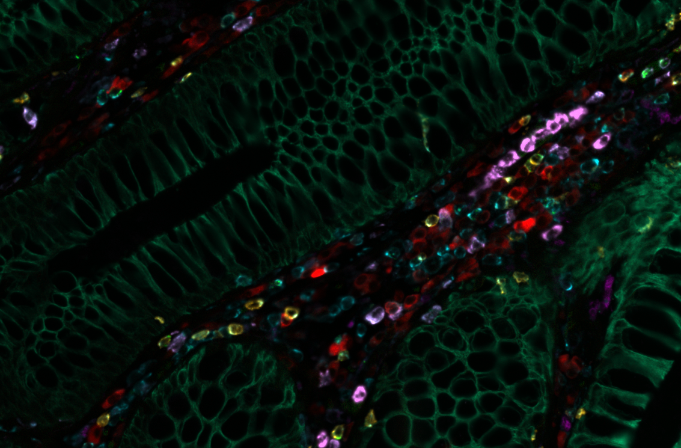Image caption:

Normal colon iteratively stained with over 30 CST antibodies using the Cell DIVE multiplexed imaging solution. Biomarkers displayed CD8A (orange); CD11B (mauve); CD68 (magenta); CD79A(red); GZMB (green); PanCK (emerald); CD45 (aqua).

___________________________________________

About Leica Microsystems
Leica Microsystems develops and manufactures microscopes and scientific instruments for the analysis of microstructures and nanostructures. Ever since the company started as a family business in the nineteenth century, its instruments have been widely recognized for their optical precision and innovative technology. It is one of the market leaders in compound and stereo microscopy, digital microscopy, confocal laser scanning microscopy with related imaging systems, electron microscopy sample preparation, and surgical microscopes.

Leica Microsystems has six major plants and product development sites around the world. The company is represented in over 100 countries, has sales and service organizations in 20 countries, and an international network of distribution partners. Its headquarters are located in Wetzlar, Germany.

About Cell Signaling Technology
Cell Signaling Technology (CST) is a different kind of life sciences company—one founded, owned, and run by active research scientists, with the highest standards of product and service quality, technological innovation, and scientific rigor. Founded in 1999 and headquartered in Danvers, Massachusetts, USA, CST employs over 400 people worldwide. We consistently provide fellow scientists around the globe with best-in-class products and services to fuel their quests for discovery. CST is a company of caring people driven by a devotion to facilitating good science—a company committed to doing the right thing for our customers, our communities, and our planet.

CST Media and Press:
Rebecca J. Reppucci, MBA, Senior Director, Global MarComm & Technology
rebecca.reppucci@cellsignal.com
978-880-3334
www.cellsignal.com

