**Leica Microsystems advances mastery and precision in complex surgeries with ARveo 8x**

**Hybrid surgical microscope empowers surgeons to perform neurosurgery, spine, and reconstructive procedures with freedom and flexibility.**

**30 June 2025, Wetzlar, Germany –­** Leica Microsystems, a Danaher company and a leading provider of microscopy and scientific instrumentation, has launched ARveo 8x, a hybrid surgical microscope for neurosurgery, spine, and plastic reconstructive procedures. It blends high-quality Leica optics with 3D visualization technologies and digital data integration capabilities. With advanced illumination for tissue protection and cutting-edge fluorescence imaging solutions, ARveo 8x gives surgeons clear, detailed views during complex surgeries.

“The hybrid system of the ARveo 8x surgical microscope empowers surgeons to have freedom and flexibility to perform precise surgeries in a comfortable setting," said Aysar Ziyadeh, Vice President, Medical Business Unit, Leica Microsystems.

Designed with surgeon comfort in mind, the flexible and lightweight setup creates a smooth and efficient surgical environment. With heads-up surgery, surgeons and their teams are no longer limited by traditional oculars. 3D monitors enabling exoscopic surgery provide them with freedom of movement and enhanced teaching experiences.

Accessing digital information is easy with ARveo 8x. Surgeons can seamlessly switch between optical and digital views without any interruption in their workflow. The microscope also integrates compatible IGS system information.

With the ARveo 8x hybrid surgical microscope, Leica Microsystems continues to lead surgical innovation, helping surgeons advance their specialties and shape the future of their fields.

For more information, please visit:

<https://go.leica-ms.com/arveo8x-PR>

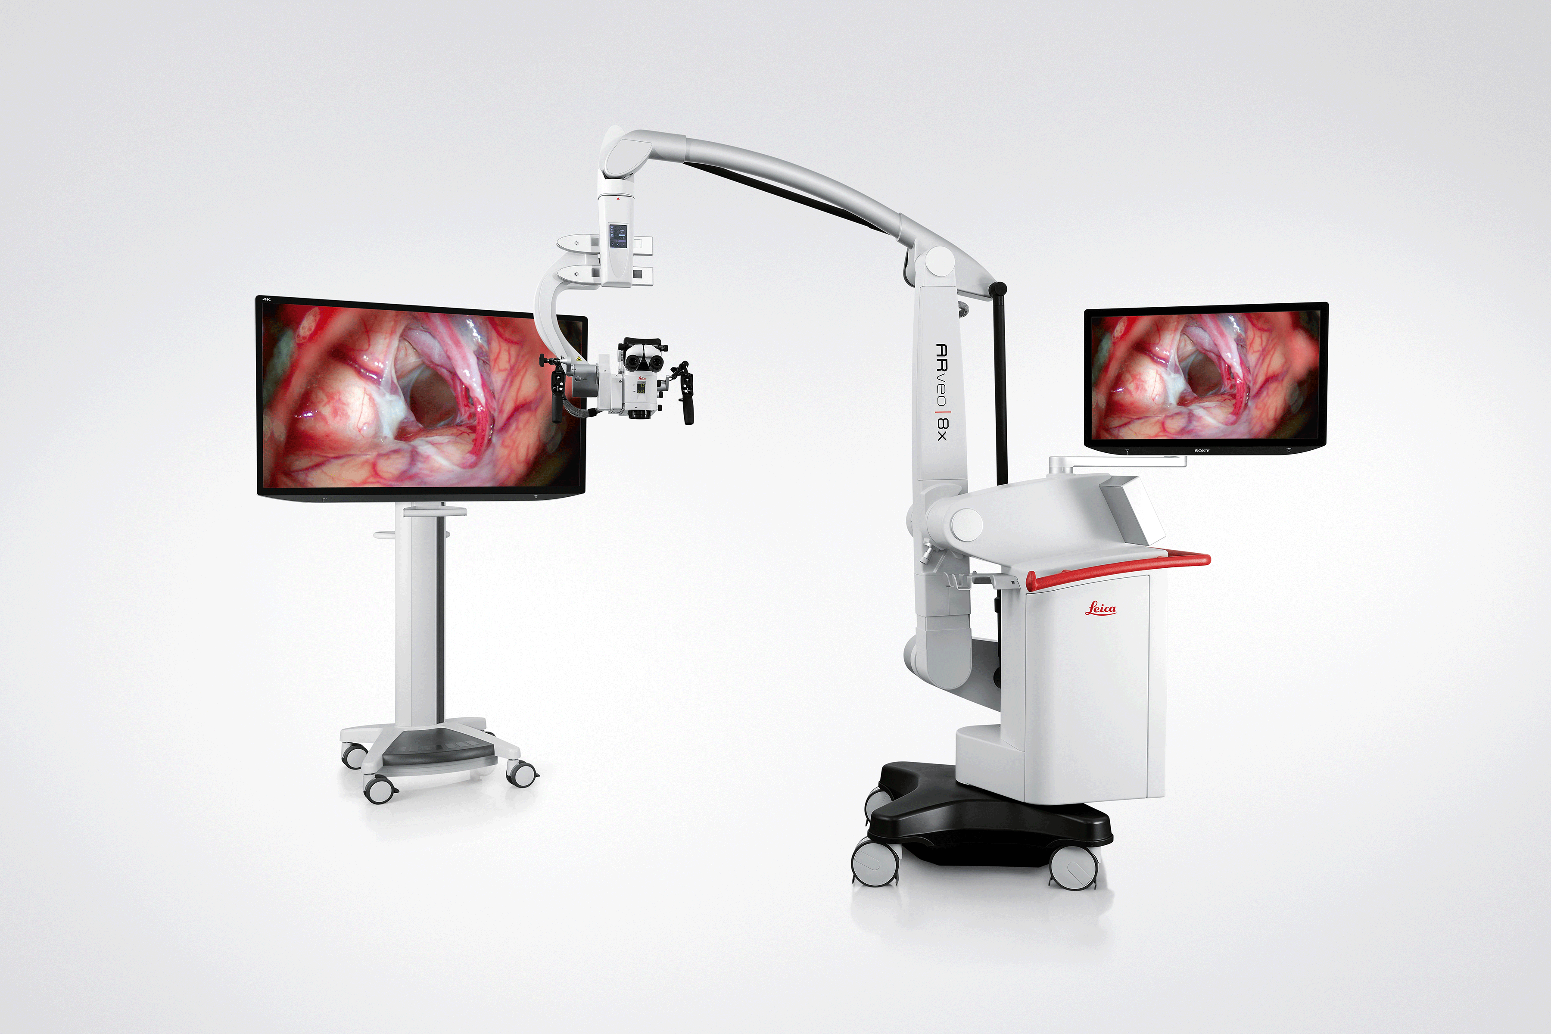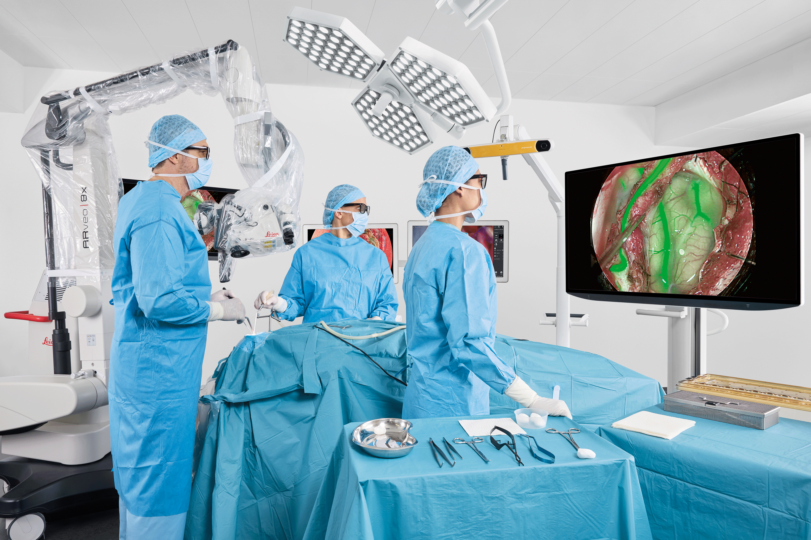

**About Leica Microsystems**

Leica Microsystems, a Danaher company, develops and manufactures fully integrated solutions for microscopic imaging and scientific instruments to analyze microstructures and nanostructures. The company empowers customers to unveil the invisible and build a better, healthier world. Widely recognized for their optical precision and innovative technology, it is one of the market leaders in compound and stereo microscopy, digital microscopy, confocal laser scanning microscopy, and surgical microscopes. Their portfolio also covers imaging workflow solutions including sample preparation and AI-enabled image analysis.

For over 175 years, Leica Microsystems has been shaping the future based on a culture rooted in customer focus and innovation. The company has six major plants and product development sites around the world. It is represented in over 100 countries, has sales and service organizations in 20 countries, and an international network of distribution partners. Its headquarters are located in Wetzlar, Germany.

Find out more at: [www.leica-microsystems.com](http://www.leica-microsystems.com)

**About Danaher**

Danaher is a leading global life sciences and diagnostics innovator, committed to accelerating the power of science and technology to improve human health. Our businesses partner closely with customers to solve many of the most important health challenges impacting patients around the world. Danaher's advanced science and technology - and proven ability to innovate - help enable faster, more accurate diagnoses and help reduce the time and cost needed to sustainably discover, develop and deliver life-changing therapies. Focused on scientific excellence, innovation and continuous improvement, our approximately 63,000 associates worldwide help ensure that Danaher is improving quality of life for billions of people today, while setting the foundation for a healthier, more sustainable tomorrow. Explore more at [www.danaher.com](https://c212.net/c/link/?t=0&l=en&o=4258988-1&h=1914481706&u=https%3A%2F%2Fwww.danaher.com%2F&a=www.danaher.com).