Leica Microsystems launches AI software module for consistent inspection decisions

Supporting manufacturers with reliable defect identification and scalable quality control across production lines

September 29, 2026, Wetzlar, Germany – Leica Microsystems, a Danaher company and a leading provider of microscopy and scientific solutions, and Cognex Corporation, the leader in industrial machine vision, today announced Aivaro AI Feature Detection, a new AI-powered software module that automatically identifies, classifies and measures defects and other features of interest during inspection. Integrated into the Enersight software platform from Leica Microsystems, the module helps production managers and engineers standardize inspection, improve efficiency and scale deployment across production environments.

“Manufacturers need a practical way to improve inspection consistency and productivity,” said Nicolas Pierre, Vice President and General Manager Life Science and Applied Solutions at Leica Microsystems. “By integrating Aivaro AI Feature Detection into the familiar Enersight platform, we are helping quality teams perform routine inspection tasks more efficiently, standardize workflows, and support consistent inspection decisions across sites and with more confidence.”

Building on industry-proven vision software AI technology from Cognex, Aivaro AI Feature Detection
offers consistent detection, classification, and measurements during routine quality control. Previous microscope settings and imaging parameters are easily reproduced to support efficient and standardized inspection workflows. The system also enables reporting of statistical values, such as minimum, maximum, and average measurements, providing additional information for quality control decisions.

Aivaro AI Feature Detection offers a ready-to-train base model, requiring only five to ten images, minimizing the effort needed to develop and train AI models, enabling rapid deployment. Inspection processes can be standardized and scaled across users, workstations, and production lines, reducing inspection time and operational costs. AI-supported onboarding makes it easy to bring new users up to speed.

This solution enables manufacturers to maintain full control of inspection decisions while using AI models directly on the production floor. Running on standard hardware and processing data locally on-site, it eliminates the need for cloud connectivity and expensive hardware. The solution is compatible with a wide range of Leica solutions.

Aivaro AI Feature Detection supports diverse manufacturing environments, including electronics, battery production, transportation, medical devices, and chemistry and polymer processing, helping companies to increase efficiency and make reliable decisions during inspection.

For more information, please visit:
https://www.leica-microsystems.com/products/microscope-software/p/aivaro/
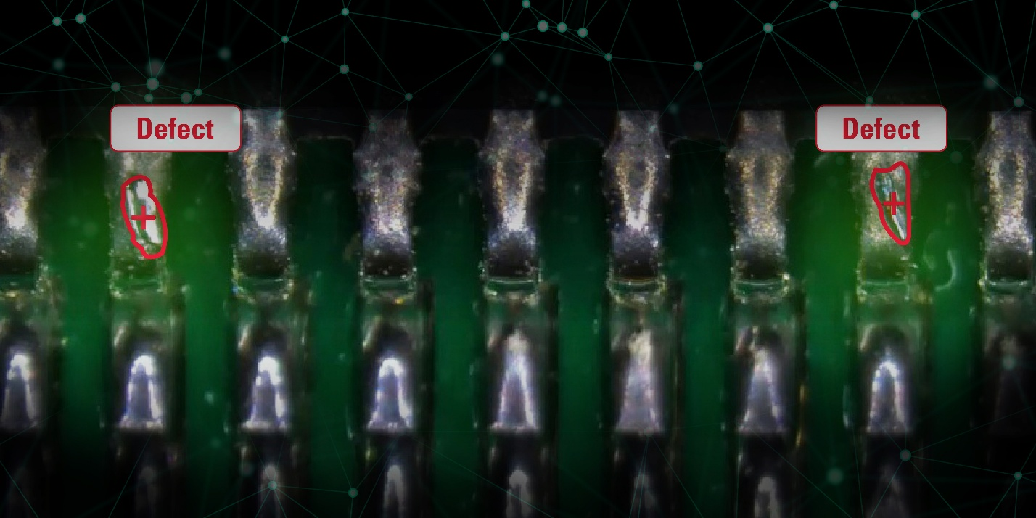
The Aivaro AI Feature Detection software module enables automated detection and measurement of defects.

About Leica Microsystems
Leica Microsystems, a Danaher company, supports the generation of insight from complex imaging data, enabling faster, informed decisions across life science, medical, and industrial applications. Guided by its purpose to reveal what is invisible, the company partners closely with customers to translate this insight into meaningful outcomes and contribute to a better and healthier world. The Leica Microsystems portfolio spans workflows from sample preparation to AI-enabled analysis. It builds on more than 175 years of expertise in microscopy, combining customer focus, continuous improvement, and innovation. As part of the Danaher ecosystem, Leica Microsystems connects imaging with complementary technologies and expertise to address broader scientific and clinical needs. Headquartered in Wetzlar, Germany, the company operates six major manufacturing and development sites and serves customers in more than 100 countries. Explore more at: https://www.leica-microsystems.com.

About Danaher
Danaher is a leading global life sciences and diagnostics innovator, committed to accelerating the power of science and technology to improve human health. Through our connected ecosystem of industry-leading businesses, we work side by side with customers to solve their most complex scientific and clinical challenges—helping move innovations from discovery to delivery faster for patients who depend on them. Powered by the Danaher Business System, our advanced science and technology and proven ability to innovate help enable faster, more accurate diagnoses and reduce the time, cost, and risk required to discover, develop, and deliver life-changing therapies. Through continuous improvement and operational excellence, our approximately 60,000 associates worldwide are focused on delivering lasting impact and improving quality of life around the world, while building a healthier, more sustainable tomorrow. Explore more at: www.danaher.com.


