Researchers gain deeper spatial insights with multiplexed 2D image analysis tool

The latest release of Aivia AI Image Analysis Software offers accurate multiplex cell detection and automatic clustering with up to 30 markers

08 November 2023, Wetzlar, Germany – Leica Microsystems, a leading provider of microscopy and scientific instrumentation, has released version 13 of Aivia, its AI image analysis software now provides a toolkit for transforming multiplexed 2D data into spatial insights. With Aivia 13, researchers can unveil spatial insights in tissues, allowing a deeper understanding of the microenvironment surrounding their phenotypes. In addition to handling large multiplexed 2D images, the new version enables researchers to obtain a comprehensive view of large image datasets, with millions of detected objects and unsupervised automatic clustering with up to 30 markers. Aivia 13 also provides a vast array of charts and spatial measurements, allowing for the collection of critical insights.

“Spatial biology methods with multiplexing and microscopy aid our understanding of normal and abnormal tissue development, such as what happens during cancer progression. Aivia is designed to help researchers reveal the invisible with profound insights into cellular and tissue structures through the power of AI,” said Luciano Lucas, Director Data & Analysis at Leica Microsystems.

“Scientists undertaking complex multiplexing tasks in translational research, cancer biology, cell biology and academia often struggle with visualizing and analyzing vast quantities of data,” said Won Yung Choi, Product Manager, Data & Analysis at Leica Microsystems. “We have developed Aivia 13 with these needs in mind, allowing researchers to rapidly identify patterns in the data and gain new levels of insights about their research fueled by easy-to-use AI tools.”

Aivia now offers scientists an end-to-end solution for visual analysis, classification, and insight creation in a single application. Moreover, researchers can perform quantitative analyses, both individually and across phenotypes or clusters.

Aivia 13 is available through a flexible subscription model, allowing users to choose a plan that aligns with their specific lab requirements. Existing Aivia subscribers can access Aivia 13 as part of their subscription, ensuring a seamless transition to this cutting-edge platform. To learn more about Aivia or to request a free trial, visit https://www.leica-microsystems.com/aivia.

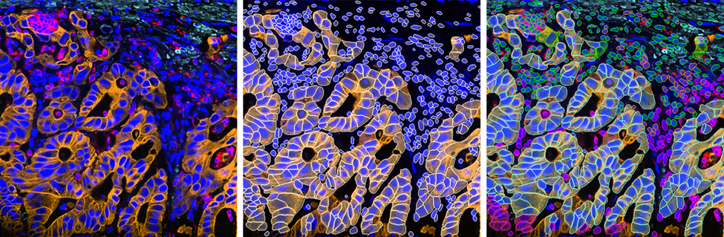
Image caption
2D slice of colon cancer tissue stained with 30 markers and imaged using the Cell DIVE system. Analysis performed using Aivia 13’s new multiplex cell detection recipe and automatic clustering tool. Original image (left), detected cell membrane shown in white (middle), each phenotype denoted in a different color (right).

___________________________________________

About Leica Microsystems
Leica Microsystems develops and manufactures microscopes and scientific instruments for the analysis of microstructures and nanostructures. Ever since the company started as a family business in the nineteenth century, its instruments have been widely recognized for their optical precision and innovative technology. It is one of the market leaders in compound and stereo microscopy, digital microscopy, confocal laser scanning microscopy with related imaging systems, electron microscopy sample preparation, and surgical microscopes.

Leica Microsystems has six major plants and product development sites around the world. The company is represented in over 100 countries, has sales and service organizations in 20 countries, and an international network of distribution partners. Its headquarters are located in Wetzlar, Germany.

Additional image 1: Cell detection
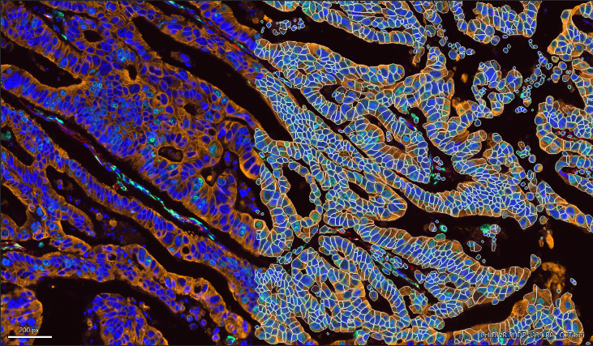

Additional image 2: Dimensionality Reduction (UMAP) 