**Latest AI software simplifies image analysis and speeds up insights for scientists**

**The Aivia 15 release includes deep learning-powered tools for 2D and 3D cell segmentation**

**08 May 2025, Wetzlar, Germany –** Leica Microsystems, a leading provider of microscopy and scientific instrumentation, has released the latest version of its AI-driven image analysis software. Aivia 15 empowers scientists to set up quickly, deploy intuitive AI-powered analysis for accurate detection, and then easily batch process their analyses.

Usability is at the heart of the latest version of Aivia, with new tools such as Segment by Example, which enables users to paint directly on 2D or 3D sample cells to deploy an AI model modified from Cellpose[1]. This deep learning engine delivers accurate segmentation across varying cellular morphologies using only a few examples, allowing any scientist to access rapid insights without needing to code or train their own models.

With the new Aivia Launchpad, users are guided through analysis setup using an intuitive interface featuring pre-built Guided Sequences and embedded tutorials. Aivia then automatically recommends relevant workflows based on user goals and image dimensions, while the Flexible Chevrons feature enables intuitive customization, saving, and sharing of workflows.

"Aivia 15 represents a major step forward in accessibility and performance for AI-powered microscopy analysis, democratizing AI to empower scientists to transform images into insights effortlessly, without deep learning expertise or coding skills," said Won Yung Choi, Product Manager, Data & Analysis at Leica Microsystems.

Tailored for researchers in neuroscience, cell biology, spatial biology applications and a wide range of other disciplines, Aivia 15 now allows scientists to focus even more on the quantitative insights gained from their data.

Performance has also taken a major leap forward. Enhanced 3D processing delivers results up to 69% faster[2], streamlining even the most demanding volumetric analysis tasks. The new Workflow Creator simplifies batching setup for segmentation, classification, and spatial relations analysis – and the updated Spatial Relations tool allows for advanced object-based spatial insights, including colocalization and nearest neighbor metrics.

Further expanding active collaboration with the scientific open-source community, Aivia 15 adds drag-and-drop support for 22 new Bioimage.io models, bringing the total to 26 pre-converted Bio Zoo models ready to use within Aivia’s recipe console.

Aivia 15 is available through flexible licensing models that provide users with options to meet their specific lab requirements. Existing Aivia users with active support and upgrade can access Aivia 15 for a seamless transition to this cutting-edge update. To learn more about Aivia or to request a free trial, visit https://www.leica-microsystems.com/aivia

**Image & caption**

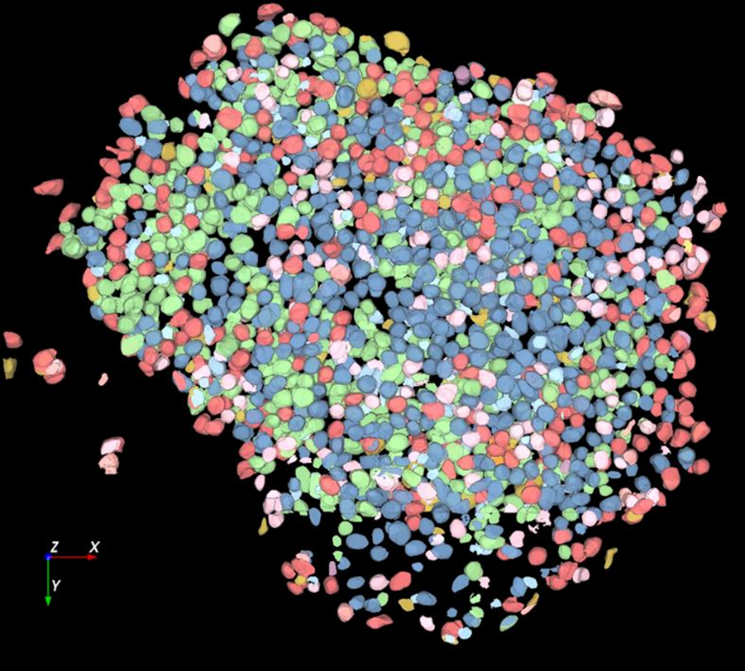

*Large volume computational clearing processed Thunder image of human pancreatic islet organoid. Cells segmented using Segment By Example tool, automatically phenotyped, and color-coded based on phenotypes in Aivia. Image courtesy of the Matthias von Herrath Lab, La Jolla Institute of Immunology, La Jolla, CA.*

___________________________________________

**About Leica Microsystems**

Leica Microsystems develops and manufactures microscopes and scientific instruments for the analysis of microstructures and nanostructures. Ever since the company started as a family business in the nineteenth century, its instruments have been widely recognized for their optical precision and innovative technology. It is one of the market leaders in compound and stereo microscopy, digital microscopy, confocal laser scanning microscopy with related imaging systems, electron microscopy sample preparation, and surgical microscopes.

Leica Microsystems has six major plants and product development sites around the world. The company is represented in over 100 countries, has sales and service organizations in 20 countries, and an international network of distribution partners. Its headquarters are located in Wetzlar, Germany.

1. Stringer C, Wang T, Michaelos M, Pachitariu M. Cellpose: a generalist algorithm for cellular segmentation. Nature Methods. 18: 100-106. (2021)
2. Compared to previous version Aivia 14