Leica Microsystems Advances AI-Powered Analysis for Multi-well Assays with Aivia 16

Software enhancements help researchers simplify complex studies and generate results with confidence

28 May 2026, Wetzlar, Germany – Leica Microsystems, a Danaher company and a leading provider of microscopy and scientific solutions, announced today the release of Aivia 16, the newest version of its AI-powered image analysis software, helping researchers analyze complex multi-well assay data faster and with greater confidence, accelerating the path from experiment to insight. Designed to address the complexity of multi-well assays that generate large datasets across multiple conditions, Aivia 16 automates workflows for data import, segmentation, and analysis. Enhanced cell segmentation powered by deep learning and interactive analysis tools further help researchers interpret results with greater speed and certainty.

“Modern life sciences research demands intuitive tools that can handle large datasets, multiplexed images, and high-content analyses,” said Won Yung Choi, Product Manager and Scientific Innovation Manager AI at Leica Microsystems. “With Aivia 16, scientists can confidently extract meaningful results from complex experiments on a single platform for image analysis. This supports more actionable insights to accelerate scientific discovery.”

Researchers can also visualize multi-well data using interactive heatmaps, dose-response curves, and quadrant gating in scatterplots. For clearer insight into cell responses to treatments, researchers can obtain automated curve fitting and IC50/EC50 calculations. Summary reports are generated automatically for simplified documentation and communication, and the results can be exported for downstream analysis.

Aivia 16 further advances cell analysis capabilities with deep learning updates that enable accurate multi-compartment cell analysis from multiple channel inputs with only a few examples. To enable faster quantification for applications such as counting assays, a new AI model enables faster cell detection by up to 12.8x compared to previous algorithms.

Aivia 16 is available through flexible licensing models that provide users with options to meet their specific lab requirements. Existing Aivia users with active support and upgrade agreements can access Aivia 16 for a seamless transition to this latest release. To learn more about Aivia 16 or to request a free trial, visit our product page at https://www.leica-microsystems.com/aivia.

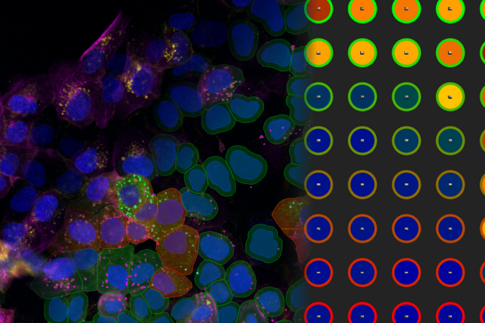

Composite image of a four color assay of cultured U2OS cells (left) and multiwell heatmap (right). The U2OS cells are stained for nuclei (SPY555), actin (ATTO 647N), WGA (AlexaFluor 405), and MX1 (GFP) imaged with a HC PL APO 20x/0.75 dry objective on a Mica system. Cell outlines generated using Segment by Example in Aivia are overlaid on the image. Sample courtesy of Dr. Patric Pelzer, Leica Microsystems CMS GmbH, Wetzlar, Germany

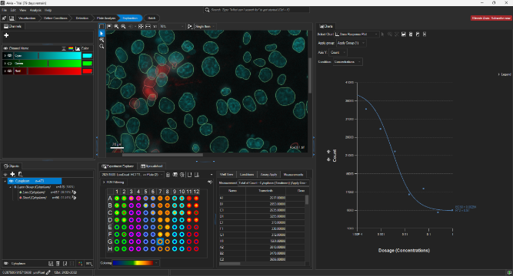
Aggregate multi-well analysis results exploration with multi-well heatmap and dose response curve with automatic IC50/EC50 calculations. Image courtesy of Dr. Won Yung Choi, Leica Microsystems, Inc., Bellevue, WA.

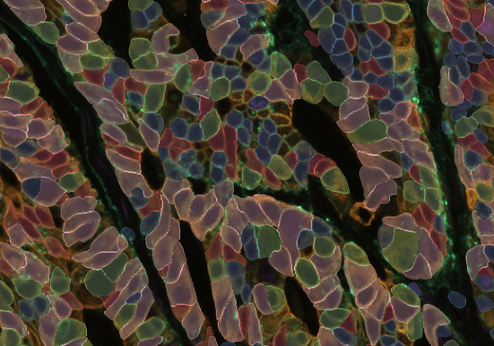
Multiplex cell detection in a colon adenocarcinoma tissue section with NAK, PanCK, and EPCAM channels using Segment by Example. Image Courtesy of Dr. Melinda Angus-Hill, Leica Microsystems Inc., Bellevue, WA.

___________________________________________

About Leica Microsystems
Leica Microsystems, a Danaher company, supports the generation of insight from complex imaging data, enabling faster, informed decisions across life science, medical, and industrial applications. Guided by its purpose to reveal what is invisible, the company partners closely with customers to translate this insight into meaningful outcomes and contribute to a better and healthier world. The Leica Microsystems portfolio spans workflows from sample preparation to AI-enabled analysis. It builds on more than 175 years of expertise in microscopy, combining customer focus, continuous improvement, and innovation. As part of the Danaher ecosystem, Leica Microsystems connects imaging with complementary technologies and expertise to address broader scientific and clinical needs. Headquartered in Wetzlar, Germany, the company operates six major manufacturing and development sites and serves customers in more than 100 countries. Explore more at: https://www.leica-microsystems.com

For over 175 years, Leica Microsystems has been shaping the future based on a culture rooted in customer focus and innovation. The company has six major plants and product development sites around the world. It is represented in over 100 countries, has sales and service organizations in 20 countries, and an international network of distribution partners. Its headquarters are located in Wetzlar, Germany.

Find out more at: www.leica-microsystems.com

About Danaher

Danaher is a leading global life sciences and diagnostics innovator, committed to accelerating the power of science and technology to improve human health. Through our connected ecosystem of industry-leading businesses, we work side by side with customers to solve their most complex scientific and clinical challenges—helping move innovations from discovery to delivery faster for patients who depend on them. Powered by the Danaher Business System, our advanced science and technology and proven ability to innovate help enable faster, more accurate diagnoses and reduce the time, cost, and risk required to discover, develop, and deliver life-changing therapies. Through continuous improvement and operational excellence, our approximately 60,000 associates worldwide are focused on delivering lasting impact and improving quality of life around the world, while building a healthier, more sustainable tomorrow. Explore more at www.danaher.com.

