Leica Microsystems appoints Diamond Dent Trading Co as Authorized Partner for Dental Surgical Microscopy Solutions in Saudi Arabia

February 2026, Wetzlar, Germany – Leica Microsystems, a Danaher company and a leading provider of microscopy and scientific solutions, has appointed Diamond Dent Trading Co as its partner in Saudi Arabia, with the partnership effective since 2025, for the distribution of Dental Surgical Microscopy Solutions.

Under this partnership, Diamond Dent Trading Co will distribute Leica Microsystems’ dental surgical microscopes to dental clinics and professionals in the Kingdom. The collaboration supports local access to microscopy solutions used in dental applications, including endodontics, restorative dentistry and microsurgical procedures.

In addition to product distribution, the partnership enables training and educational activities related to Leica dental microscopes. These may include product demonstrations, application focused sessions, and hands-on trainings, providing dental professionals with opportunities to familiarize themselves with microscope use in clinical settings.

“This partnership allows us to work closely with a local organization to support product availability and education in the Saudi Arabian market,” said Vanessa Lurquin, EMEA Sales Director - Medical Division at Leica Microsystems.

Commenting on the collaboration, Abdulrahman Al-Fawaz, CEO at Diamond Dent Trading Co stated: “Working with Leica Microsystems enables us to support dental professionals in Saudi Arabia with access to dental surgical microscopy solutions, alongside training and educational activities. This collaboration aligns with our ongoing focus on supporting clinicians through product availability and professional engagement.”

Diamond Dent Trading Co will serve as the local point of contact for product information, demonstrations, and training coordination.

Leica Microsystems and Diamond Dent Trading Co will work together to support dental professionals through product distribution and educational engagement in Saudi Arabia.

About Diamond Dent Trading Co
Diamond Dent Trading Co was founded with the aim of supporting dental product distribution in Saudi Arabia. The company works with international dental manufacturers to support product availability and commercial activities for dental clinics and professionals across the Kingdom. The company is committed to working with partners and clinicians to contribute to the ongoing development of dental care in Saudi Arabia.

As Leica Microsystems’ authorized partner for dental surgical microscopy solutions, Diamond Dent Trading Co supports local commercial activities and educational engagements related to dental microscopy in Saudi Arabia.
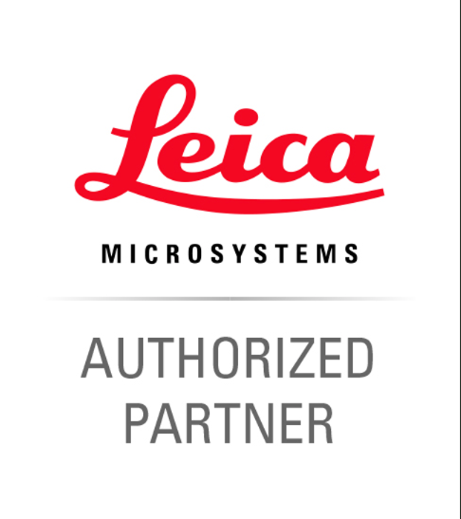
About Leica Microsystems
Leica Microsystems, a Danaher company, develops and manufactures fully integrated solutions for microscopic imaging and scientific instruments to analyze microstructures and nanostructures. The company empowers customers to unveil the invisible and build a better, healthier world. Widely recognized for their optical precision and innovative technology, it is one of the market leaders in compound and stereo microscopy, digital microscopy, confocal laser scanning microscopy, and surgical microscopes. Their portfolio also covers imaging workflow solutions including sample preparation and AI-enabled image analysis.
For over 175 years, Leica Microsystems has been shaping the future based on a culture rooted in customer focus and innovation. The company has six major plants and product development sites around the world. It is represented in over 100 countries, has sales and service organizations in 20 countries, and an international network of distribution partners. Its headquarters are located in Wetzlar, Germany.
Find out more at: www.leica-microsystems.com

About Danaher
Danaher is a leading global life sciences and diagnostics innovator, committed to accelerating the power of science and technology to improve human health. Our businesses partner closely with customers to solve many of the most important health challenges impacting patients around the world. Danaher's advanced science and technology - and proven ability to innovate - help enable faster, more accurate diagnoses and help reduce the time and cost needed to sustainably discover, develop and deliver life-changing therapies. Focused on scientific excellence, innovation and continuous improvement, our approximately 63,000 associates worldwide help ensure that Danaher is improving quality of life for billions of people today, while setting the foundation for a healthier, more sustainable tomorrow.
Explore more at www.danaher.com.

