Leica Microsystems expands online shopping experience to Spain and Switzerland
Customers gain access to microscopy solutions, software, and localized purchasing options in their local languages
XX June 2026, Wetzlar, Germany – Leica Microsystems, a Danaher company and a leading provider of microscopy and scientific solutions, has expanded its online shopping experience to Spain and Switzerland, bringing an enhanced and localized digital store to customers in both countries.
For the first time, customers in these markets can purchase microscopy software solutions, including Enersight, while also requesting quotes for Leica Microsystems’ advanced imaging portfolio through a modern, intuitive online interface—with fast turnaround times to support efficient decision-making. To celebrate the launch, customers will also benefit from free shipping on eligible orders through the end of 2026, excluding ATTO products.
“This expansion marks another important step in making our digital purchasing experience more accessible and relevant to customers across Europe,” said Walid Beylouni, Senior Vice President Global Commercial Operations at Leica Microsystems. “By bringing our localized online store to Spain and Switzerland and introducing software solutions such as Enersight for direct purchase, we are giving customers greater flexibility to access the tools they need to accelerate discovery and improve workflows.”
The launch in Spain and Switzerland is designed to support researchers, clinicians, educators, and industrial professionals with a streamlined purchasing experience tailored to their local market. Customers can browse products in their local language, compare solutions, view pricing, purchase directly online, or request a quote—all within a seamless digital platform designed to simplify access to Leica Microsystems’ technologies.
For more information, please visit https://www.leica-microsystems.com/shop/
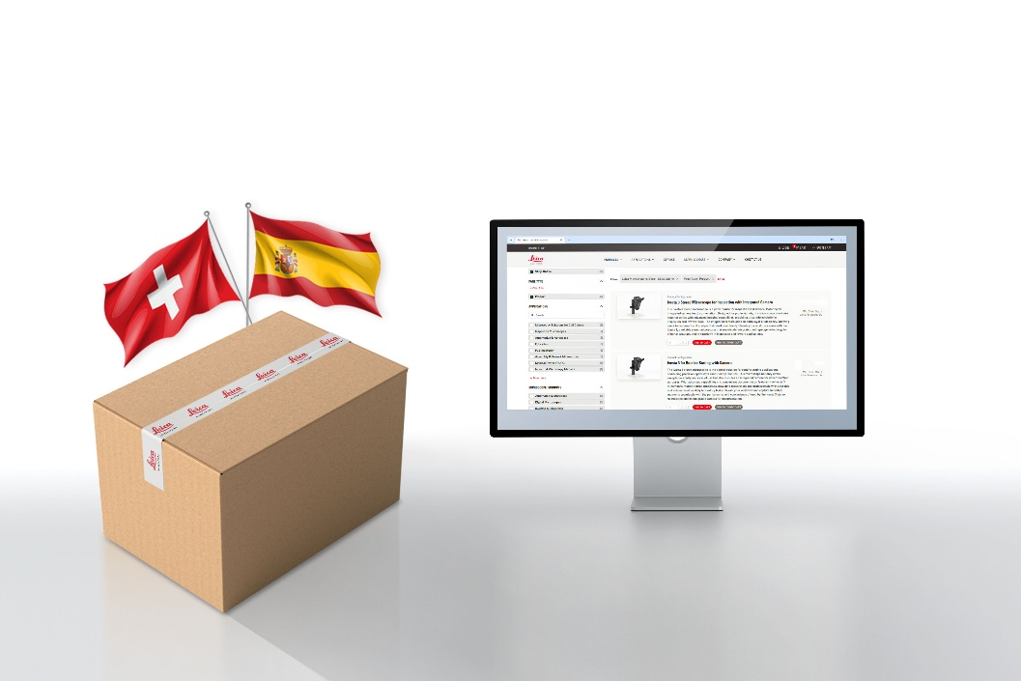

Free shipping terms and conditions
- Free Shipping available until December 31, 2026 for purchases made exclusively through the Leica Online Store
- Orders must be placed online during the promotional period to qualify
- Excludes ATTO-Tec products.
- Offer is valid for free standard shipping only. No other shipping options are available under this promotion.
- Requests for quote (RFQs) are not included in this offer.
- Offer cannot be combined with any other promotional offers or discounts.
- The Online Store is not offered in every market, and configurations may vary between countries. Please contact your local Leica representative for further information.

