Lowering barriers to scalable multiplex spatial biology

The Launch Early Access Program (LEAP) from Leica Microsystems provides supported access to the ATTOAuriga reagent platform

20 April 2026, Wetzlar, Germany – Leica Microsystems, a Danaher company and a leading provider of microscopy and scientific solutions, announced today that its Launch Early Access Program (LEAP) is now available, offering supported early access to ATTOAuriga, a novel spatial biology reagent platform in its pre-launch phase. LEAP helps labs evaluate workflows with real samples early on, without committing to fixed assay designs.

Spatial biology is advancing quickly, yet many labs still face complex workflows and limited flexibility. LEAP provides a structured pathway, with application and workflow support. This helps researchers generate and evaluate data with confidence. ATTOAuriga is a modular reagent ecosystem. It is built on bright ATTO dye chemistry and a barcode-based architecture for scalable multiplexing. It brings together pre-validated panels, antibody conjugation kits, and supporting reagents in a single workflow designed for reproducibility, sensitivity, and flexibility as research needs evolve.

“Researchers want to adopt spatial biology at their own pace, starting with data generation they can rely on and scaling as their questions evolve,” said James O’Brien, Vice President Life Sciences & Applied Solutions, Leica Microsystems. “With LEAP and ATTOAuriga, scientists can access preliminary spatial data from their own samples and evaluate workflows without being tightly constrained into fixed assay designs or rigid workflows.”

Researchers can start with ready-to-use core panels to reduce setup time and support consistent, reproducible results. The same workflow supports panel expansion and customization as studies evolve without full revalidation. With supported early access to the flexible ATTOAuriga reagent platform, LEAP is designed to enable proof-of-concept studies, and generate data that may support grant applications, and inform adoption decisions. Within LEAP, the AI-enabled image analysis software Aivia supports an end-to-end workflow, from multiplex image acquisition through quantitative, reportable outputs to support downstream decision-making.

ATTOAuriga and the Launch Early Access Program (LEAP) were presented at the AACR 2026
Annual Conference, offering visitors a closer look at how scalable multiplex spatial biology workflows
can be evaluated and expanded. Beyond the event, LEAP is intended to support broader access to
these workflows, enabling researchers to evaluate them with their own samples at an early stage
and make informed adoption decisions. Further information is available at www2.leica-microsystems.com/attoauriga.

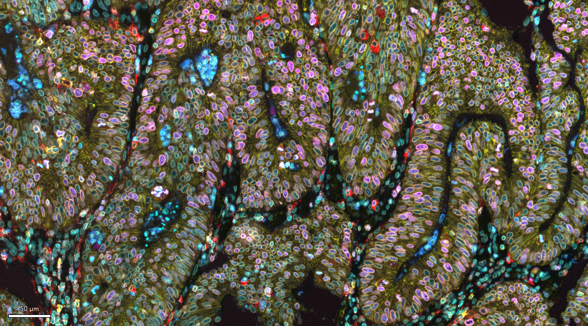
Image caption:
Multiplexed immunofluorescence image of a human colon mucinous adenocarcinoma FFPE tissue section labeled with the ATTOApollo panel, featuring CD45, Ki67, CD11b, CD68, E‑cadherin, Lamin B1, CD20, CD14, and DAPI.

___________________________________________

About Leica Microsystems
Leica Microsystems, a Danaher company, develops and manufactures fully integrated solutions for microscopic imaging and scientific instruments to analyze microstructures and nanostructures. The company empowers customers to unveil the invisible and build a better, healthier world. Widely recognized for their optical precision and innovative technology, it is one of the market leaders in compound and stereo microscopy, digital microscopy, confocal laser scanning microscopy, and surgical microscopes. Their portfolio also covers imaging workflow solutions including sample preparation and AI-enabled image analysis.
For over 175 years, Leica Microsystems has been shaping the future based on a culture rooted in customer focus and innovation. The company has six major plants and product development sites around the world. It is represented in over 100 countries, has sales and service organizations in 20 countries, and an international network of distribution partners. Its headquarters are located in Wetzlar, Germany.

Find out more at: www.leica-microsystems.com

About Danaher
Danaher is a leading global life sciences and diagnostics innovator, committed to accelerating the power of science and technology to improve human health. Through our connected ecosystem of industry-leading businesses, we work side by side with customers to solve their most complex scientific and clinical challenges—helping move innovations from discovery to delivery faster for patients who depend on them. Powered by the Danaher Business System, our advanced science and technology and proven ability to innovate help enable faster, more accurate diagnoses and reduce the time, cost, and risk required to discover, develop, and deliver life-changing therapies. Through continuous improvement and operational excellence, our approximately 60,000 associates worldwide are focused on delivering lasting impact and improving quality of life around the world, while building a healthier, more sustainable tomorrow. Explore more at www.danaher.com.


