Leica Microsystems expands online shopping experience to France and Italy

Customers gain access to microscopy solutions and reagents in local languages

19 March 2026, Wetzlar, Germany – Leica Microsystems, a Danaher company and a leading provider of microscopy and scientific solutions, has expanded its online shopping experience in France and Italy, bringing an enhanced and localized digital store to customers in both countries. For the first time, users can purchase high-quality ATTO-TEC reagents directly alongside tailored microscopy solutions from a modern, intuitive interface. Leica Microsystems now offers a unified workflow for researchers who rely on both advanced microscopes and reliable consumables for sample preparation and imaging.

“We are excited to offer customers in France and Italy a more convenient and personalized way to navigate our microscopy portfolio,” said Walid Beylouni, Senior Vice President Global Commercial Operations at Leica Microsystems. “By extending our digital store to these countries with the inclusion of ATTO-TEC consumables, we continue to deliver on our commitment to innovation and accessibility for our customers.”

This expansion to France and Italy aims to empower researchers, clinicians, and industrial users with the tools they need to work with efficiency and precision. They can explore different options, compare features, check prices, and either add items to their order or request an online quote – all in one place and in their local language.

For more information, please visit https://www.leica-microsystems.com/shop/

___________________________________________

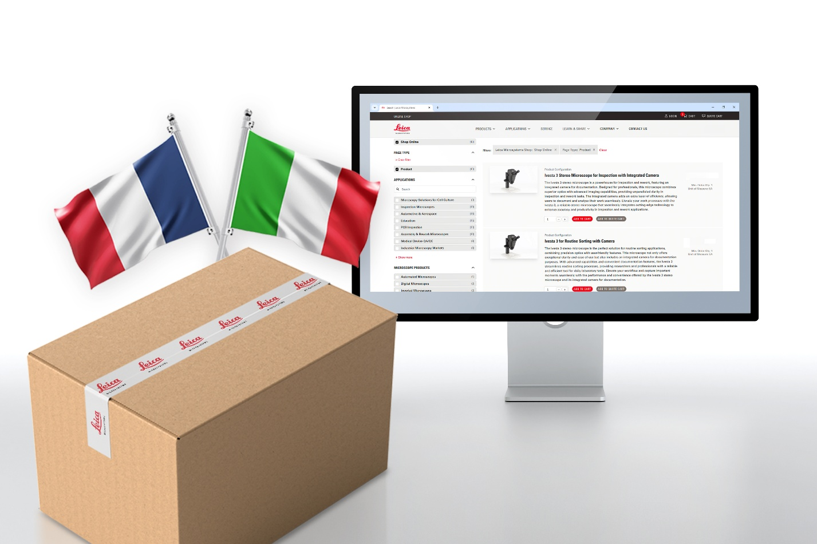
About Leica Microsystems
Leica Microsystems, a Danaher company, develops and manufactures fully integrated solutions for microscopic imaging and scientific instruments to analyze microstructures and nanostructures. The company empowers customers to unveil the invisible and build a better, healthier world. Widely recognized for their optical precision and innovative technology, it is one of the market leaders in compound and stereo microscopy, digital microscopy, confocal laser scanning microscopy, and surgical microscopes. Their portfolio also covers imaging workflow solutions including sample preparation and AI-enabled image analysis.

For over 175 years, Leica Microsystems has been shaping the future based on a culture rooted in customer focus and innovation. The company has six major plants and product development sites around the world. It is represented in over 100 countries, has sales and service organizations in 20 countries, and an international network of distribution partners. Its headquarters are located in Wetzlar, Germany.

Find out more at: www.leica-microsystems.com
About Danaher

Danaher is a leading global life sciences and diagnostics innovator, committed to accelerating the power of science and technology to improve human health. Our businesses partner closely with customers to solve many of the most important health challenges impacting patients around the world. Danaher's advanced science and technology - and proven ability to innovate - help enable faster, more accurate diagnoses and help reduce the time and cost needed to sustainably discover, develop and deliver life-changing therapies. Focused on scientific excellence, innovation and continuous improvement, our approximately 63,000 associates worldwide help ensure that Danaher is improving quality of life for billions of people today, while setting the foundation for a healthier, more sustainable tomorrow. Explore more at www.danaher.com.

