Leica Microsystems expands online shopping experience to UK customers

New platform with AI-powered search gives customers convenient access to tailored microscopy solutions

24 June 2025, Wetzlar, Germany – Leica Microsystems, a Danaher company and a leading provider of microscopy and scientific solutions, has expanded its online shopping experience to the United Kingdom. UK customers will be the first in Europe to enjoy the convenience and personalisation of this digital store. Initially launched in the United States last year, UK customers now have a straightforward way to find the best microscope for their specific needs. They can explore different options, compare features, check prices, and either add items to their order or request an online quote.

“We are excited to bring our new online shopping experience to the UK, providing our customers with a smooth and personalized experience from discovery to delivery and beyond. This expansion means that more customers can find the optimal solution for their microscopy needs and order online,” said Walid Beylouni, Senior Vice President Global Commercial Operations at Leica Microsystems. “With a platform that enables easy access to microscopy solutions, we aim to support our customers in their quality control, ongoing research and development efforts.”

Channel partners of Leica Microsystems will also benefit from the introduction of the catalogue. It empowers them with detailed product information, including images and specifications, and automated catalogue maintenance for their own e-commerce sites. By ensuring channel partners have access to accurate and up-to-date information, they can confidently showcase products.

Leica Microsystems is committed to meeting the evolving needs of its valued customers and partners in the UK with a modern, customer-first user experience.

For more information, please visit https://www.leica-microsystems.com/shop/

___________________________________________

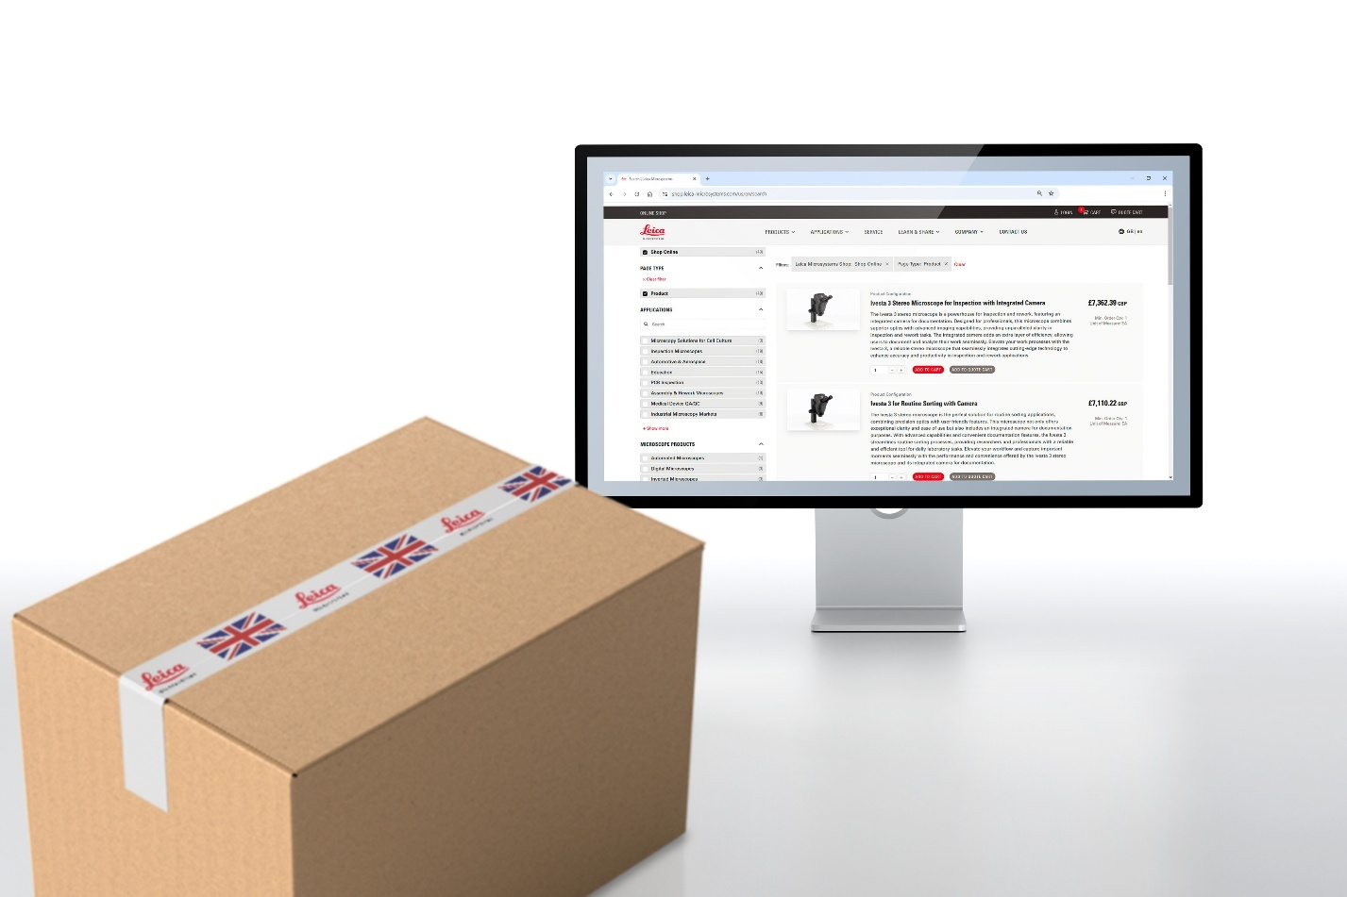
About Leica Microsystems
Leica Microsystems, a Danaher company, develops and manufactures fully integrated solutions for microscopic imaging and scientific instruments to analyze microstructures and nanostructures. The company empowers customers to unveil the invisible and build a better, healthier world. Widely recognized for their optical precision and innovative technology, it is one of the market leaders in compound and stereo microscopy, digital microscopy, confocal laser scanning microscopy, and surgical microscopes. Their portfolio also covers imaging workflow solutions including sample preparation and AI-enabled image analysis.

For over 175 years, Leica Microsystems has been shaping the future based on a culture rooted in customer focus and innovation. The company has six major plants and product development sites around the world. It is represented in over 100 countries, has sales and service organizations in 20 countries, and an international network of distribution partners. Its headquarters are located in Wetzlar, Germany.

Find out more at: www.leica-microsystems.com
About Danaher

Danaher is a leading global life sciences and diagnostics innovator, committed to accelerating the power of science and technology to improve human health. Our businesses partner closely with customers to solve many of the most important health challenges impacting patients around the world. Danaher's advanced science and technology - and proven ability to innovate - help enable faster, more accurate diagnoses and help reduce the time and cost needed to sustainably discover, develop and deliver life-changing therapies. Focused on scientific excellence, innovation and continuous improvement, our approximately 63,000 associates worldwide help ensure that Danaher is improving quality of life for billions of people today, while setting the foundation for a healthier, more sustainable tomorrow. Explore more at www.danaher.com.

