**New upright microscopes for enhanced user efficiency and comfort**

**Leica Microsystems introduces the Visoria series to power up microscopy routines across industrial, life science and clinical applications.**

**6 May 2025, Wetzlar, Germany –** Leica Microsystems, a leading provider of microscopy and scientific instrumentation, has launched the Visoria series of upright microscopes, to help enhance the efficiency and comfort of routine microscopy work for pathologists, quality control managers, and researchers.

There are three distinct microscope models in the Visoria series, each designed to meet the needs of users for different applications in various fields. The **Visoria B laboratory** microscope is for users in life science and clinical laboratories who perform applications to support human, animal and plant histology, and pathology examinations. The **Visoria M materials** microscope isfor routine inspection in the metals, electronics, and polymer industries, as well as for materials science labs. The **Visoria P polarization** microscope isfor users studying the optical properties of anisotropic materials and geological samples.

With digital versions of the Visoria microscopes, users view and analyze images of samples directly on a tablet without the need for a computer and eyepieces. This digital setup helps users save workbench space in laboratory and production environments.

‘’The Visoria series of microscopes address the daily challenges of performing routine microscopy tasks," said James O’Brien, Vice President of Life Sciences and Applied Solutions at Leica Microsystems. "Thanks to ergonomic features and encoded functions, these microscopes help users to work comfortably and efficiently, even when spending long hours at the microscope.”

Users of Visoria microscopes save valuable time thanks to their encoding. They can focus on viewing and examining samples using the light management function. Additionally, users no longer need to adjust the brightness after changing the magnification or contrast methods. The microscope settings and imaging parameters, including filters used and magnification, are automatically stored within the meta data of the image. To simplify and streamline workflows, Visoria is powered by the Enersight software platform, which offers users a consistent and easy-to-use interface.

With ergonomic accessories, all Visoria models provide users the experience of performing routine tasks comfortably, even over extended periods. Users can maintain a proper working posture with the symmetrically positioned stage controls and adjustable focus knobs. To reduce the risk of discomfort and repetitive strain injury, the height and torque of the microscope stage control can easily be adjusted.

For more information, please visit:

<https://go.leica-ms.com/visoria-b-pr>

<https://go.leica-ms.com/visoria-m-pr>

<https://go.leica-ms.com/visoria-p-pr>

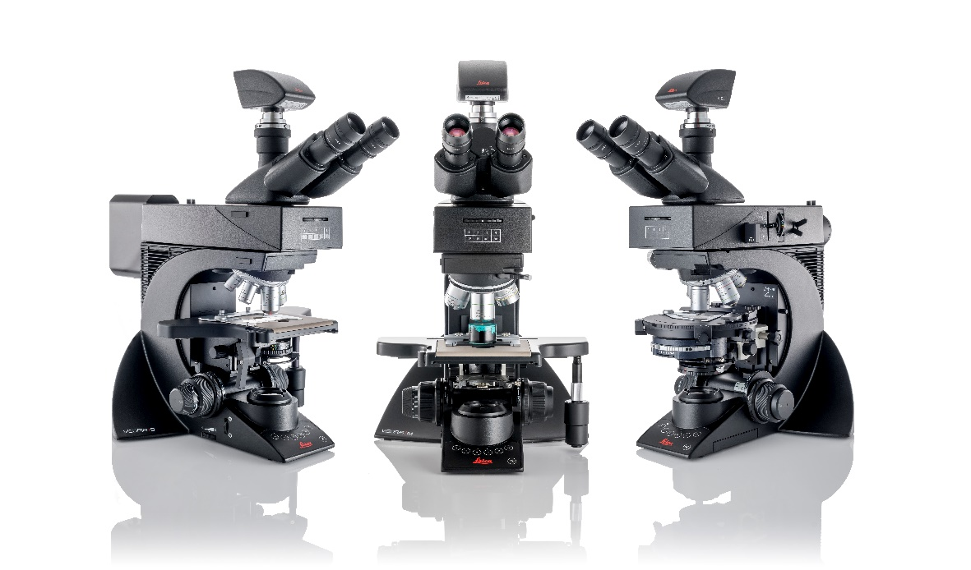

**Image caption**

The Visoria B / M / P microscopes power up your microscopy routines with efficiency and comfort.

________________________________________

**About Leica Microsystems**

Leica Microsystems develops and manufactures microscopes and scientific instruments for the analysis of microstructures and nanostructures. Ever since the company started as a family business in the nineteenth century, its instruments have been widely recognized for their optical precision and innovative technology. It is one of the market leaders in compound and stereo microscopy, digital microscopy, confocal laser scanning microscopy with related imaging systems, electron microscopy sample preparation, and surgical microscopes.

Leica Microsystems has six major plants and product development sites around the world. The company is represented in over 100 countries, has sales and service organizations in 20 countries, and an international network of distribution partners. Its headquarters are located in Wetzlar, Germany.