From live dynamics to full 3D tissue context on a single light sheet platform

The Viventis Deep light sheet microscope supports both live and cleared imaging on one configurable platform

May **, 2026, Wetzlar, Germany – Leica Microsystems, a Danaher company and a leading provider of microscopy and scientific solutions, has announced an expansion of the Viventis Deep dual view light sheet microscope with the option for cleared sample imaging enabling deep imaging of live and cleared samples within a single system. Researchers can capture dynamic processes and then add molecular and structural context, using the same platform for a clearer readout across the experiment.
“As researchers increasingly rely on complex biological models to understand physiological processes, they need imaging approaches that link functional dynamics with structural context across their experiments,” said James O’Brien, Vice President of Life Sciences and Applied Solutions at Leica Microsystems. “Viventis Deep enables teams to relate functional observations directly to tissue-level context from discovery to translation in their research.”
Viventis Deep is designed for volumetric imaging and its modular design allows researchers to exchange detection optics to match their experimental needs. Using the same instrument, teams can image optically cleared samples to place observed dynamics into full three-dimensional spatial context.
The expanded Viventis Deep dual view light sheet microscope was first presented to the research community at the Focus on Microscopy conference in March 2026. The value of combining live and cleared imaging in one platform was highlighted for applications such as developmental biology, organoids, and neuroscience. Within the broader Danaher science and technology ecosystem, Leica Microsystems aligns imaging workflows with shared standards for life science research and biotechnology.
The Viventis Deep dual view light sheet microscope is available globally through Leica Microsystems and authorized partners.
For more information, please visit www.leica-microsystems.com/products/p/viventis-deep/

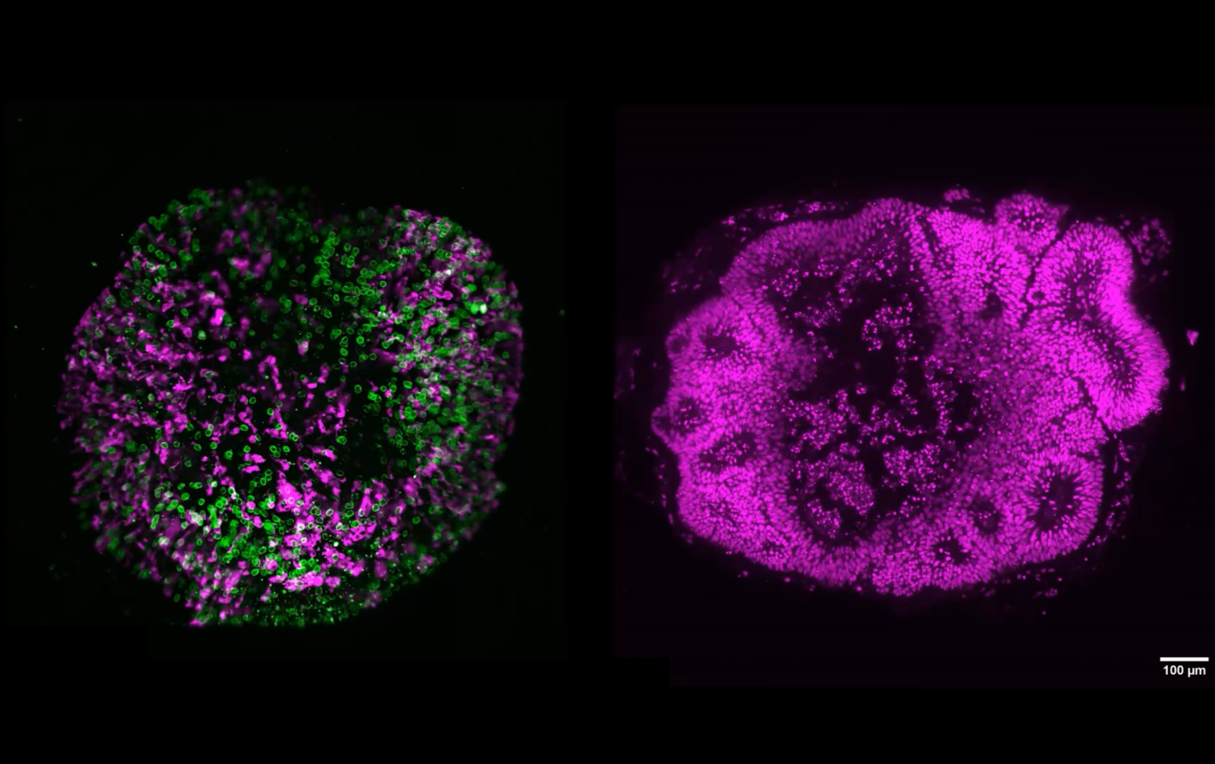
Human Brain organoid: Left: Screenshot from 40-h time-lapse of a human brain organoid. Courtesy of Akanksha Jain, Treutlein Lab ETH, D-BSSE Basel, CH. Right: Z-stack image of a cleared 60-day-old human brain organoid. Courtesy of Professor Barbara Treutlein, ETH, D-BSSE Basel, CH.

___________________________________________

About Leica Microsystems

Leica Microsystems, a Danaher company, develops and manufactures fully integrated solutions for microscopic imaging and scientific instruments to analyze microstructures and nanostructures. The company empowers customers to unveil the invisible and build a better, healthier world. Widely recognized for their optical precision and innovative technology, it is one of the market leaders in compound and stereo microscopy, digital microscopy, confocal laser scanning microscopy, and surgical microscopes. Their portfolio also covers imaging workflow solutions including sample preparation and AI-enabled image analysis.

For over 175 years, Leica Microsystems has been shaping the future based on a culture rooted in customer focus and innovation. The company has six major plants and product development sites around the world. It is represented in over 100 countries, has sales and service organizations in 20 countries, and an international network of distribution partners. Its headquarters are located in Wetzlar, Germany.

Find out more at: www.leica-microsystems.com

About Danaher

Danaher is a leading global life sciences and diagnostics innovator, committed to accelerating the power of science and technology to improve human health. Through our connected ecosystem of industry-leading businesses, we work side by side with customers to solve their most complex scientific and clinical challenges—helping move innovations from discovery to delivery faster for patients who depend on them. Powered by the Danaher Business System, our advanced science and technology and proven ability to innovate help enable faster, more accurate diagnoses and reduce the time, cost, and risk required to discover, develop, and deliver life-changing therapies. Through continuous improvement and operational excellence, our approximately 60,000 associates worldwide are focused on delivering lasting impact and improving quality of life around the world, while building a healthier, more sustainable tomorrow. Explore more at www.danaher.com.


