Fast and complex biological dynamics resolved in 3D with standard sample carriers

Leica Microsystems launches the Viventis SCAPE light sheet microscope

29 March 2026, Wetzlar, Germany – Leica Microsystems, a Danaher company and a leading provider of microscopy and scientific solutions, has launched the Viventis SCAPE light sheet microscope. Viventis SCAPE enables fast 3D light sheet imaging while using standard sample carriers. The patented SCAPE technology is designed for fast volumetric imaging. It helps researchers capture time‑critical events as they unfold in three dimensions.

“With Viventis SCAPE, our goal is to empower researchers to explore new frontiers in volumetric live‑cell imaging, enabling insights that are unattainable with other technologies,” said James O’Brien, Vice President of Life Sciences and Applied Solutions at Leica Microsystems. “It enables researchers to follow biology as it occurs, without altering physiological states, with increased throughput, and obtain results faster by resolving dynamics as they happen.”

Many biologically relevant processes happen on very short timescales. It is hard to capture them in 3D and still preserve specimen viability. Viventis SCAPE addresses that challenge. It combines fast volumetric imaging with gentle conditions. Researchers can capture fast and complex biological processes without missing critical events. They can also increase throughput to reach results sooner. This helps teams draw conclusions with more rigor and confidence.

Standard sample carriers also make studies easier to repeat and compare. They support consistent handling across conditions. This helps teams tackle complex biological questions with comparable data and consistent workflows.

This supports rigorous, efficient progression from observation to outcome in live and three‑dimensional model systems. Leica Microsystems supports this work as part of the Danaher science and technology ecosystem.
The Viventis SCAPE light sheet microscope was introduced at Focus on Microscopy (FOM) 2026 and is available globally through Leica Microsystems and authorized partners.

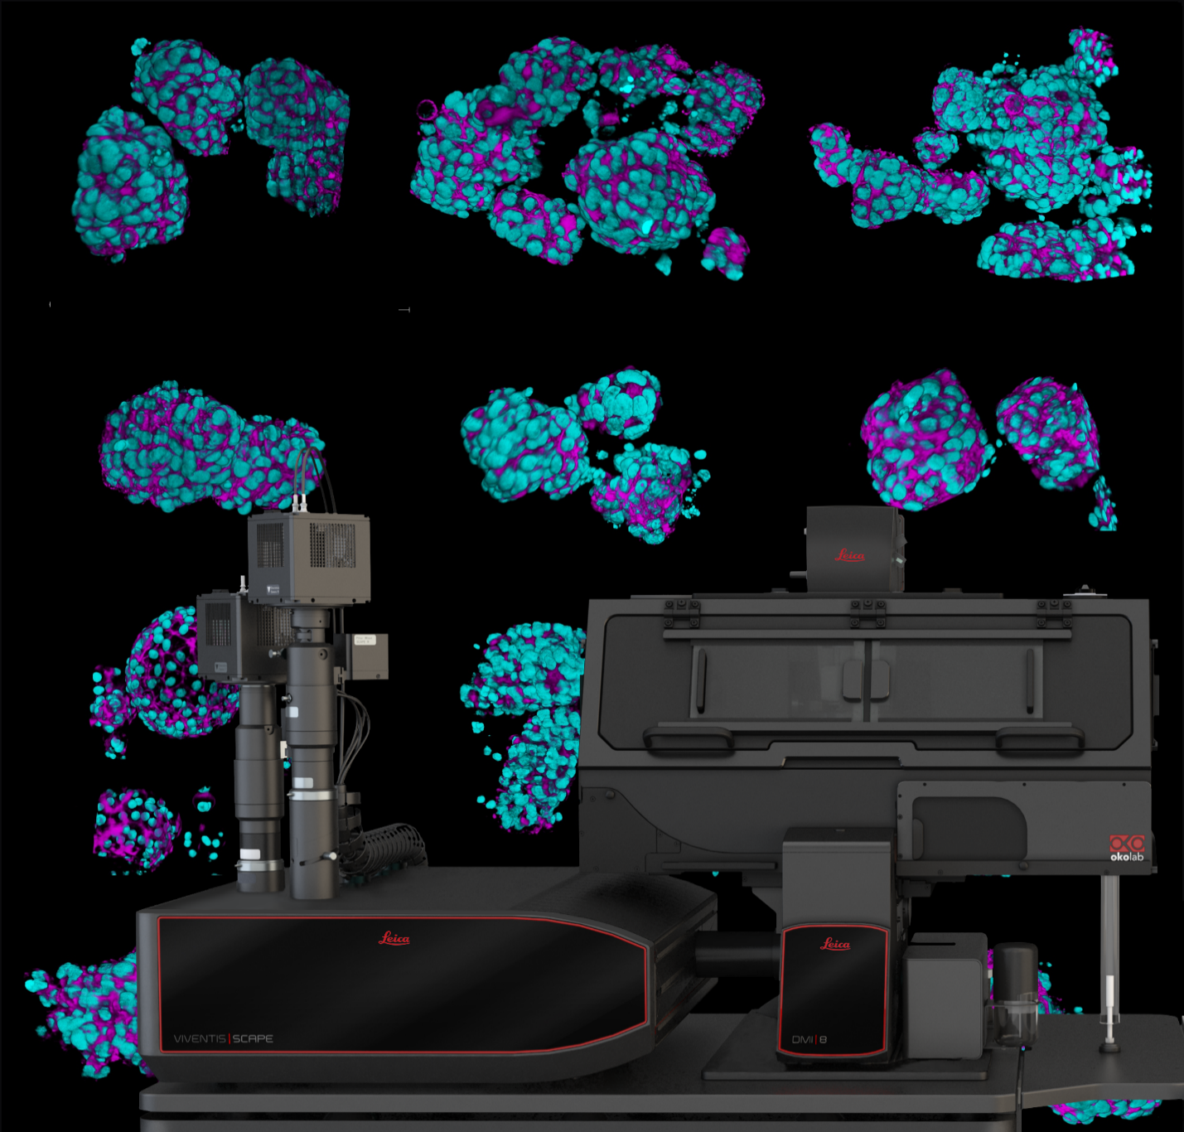
Viventis SCAPE - Single Objective Light Sheet Microscope for fast and gentle volumetric imaging

About Leica Microsystems
Leica Microsystems, a Danaher company, develops and manufactures fully integrated solutions for microscopic imaging and scientific instruments to analyze microstructures and nanostructures. The company empowers customers to unveil the invisible and build a better, healthier world. Widely recognized for their optical precision and innovative technology, it is one of the market leaders in compound and stereo microscopy, digital microscopy, confocal laser scanning microscopy, and surgical microscopes. Their portfolio also covers imaging workflow solutions including sample preparation and AI-enabled image analysis.

For over 175 years, Leica Microsystems has been shaping the future based on a culture rooted in customer focus and innovation. The company has six major plants and product development sites around the world. It is represented in over 100 countries, has sales and service organizations in 20 countries, and an international network of distribution partners. Its headquarters are located in Wetzlar, Germany.

Find out more at: www.leica-microsystems.com

About Danaher

Danaher is a leading global life sciences and diagnostics innovator, committed to accelerating the power of science and technology to improve human health. Our businesses partner closely with customers to solve many of the most important health challenges impacting patients around the world. Danaher's advanced science and technology - and proven ability to innovate - help enable faster, more accurate diagnoses and help reduce the time and cost needed to sustainably discover, develop and deliver life-changing therapies. Focused on scientific excellence, innovation and continuous improvement, our approximately 63,000 associates worldwide help ensure that Danaher is improving quality of life for billions of people today, while setting the foundation for a healthier, more sustainable tomorrow. Explore more at www.danaher.com.

